Computer Language Coding Concepts

Value Assignment in a Diagram
The principle of value assignment is explained in the article Value Assignment. This article demonstrates the expression of it in a diagram.

About the notation of assignment in general, see the article Assignment in a Diagram.

An assignment is a call to an assignment command, but the expression of an assignment call is given a more basic notation, like this:

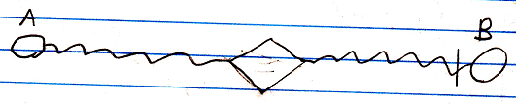

The fact, that the lines are wavy, expresses, that it is a value assignment. The access mark indicates the direction. The value of object A is assigned to object B.

See also: Assignment in a Diagram, Value Assignment

Author & Copyright: Jan-Joost van Zon Date: May 24, 2008 – July 24, 2008 Location: Oosterhout, The Netherlands Status: Finished

Ideas
Value Assignment,
2008-09-05

Actually, the notation will change. No call symbol will be visible, because a value connection is always a value assignment.

